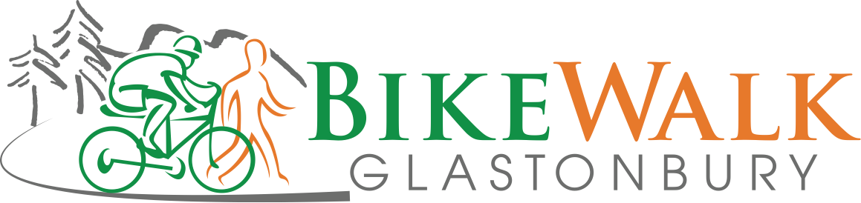

MINUTES

March 14, 2016
Contents
East Hartford and Portland connections along the Connecticut River 1
Todd Andrews of Goodwin College 1
Steve Grusberg 2
Charlie Smith of the Land Heritage Coalition 2
Helmet Donation Report 2
Kiwanis Tour of Glastonbury 2
Audubon Society Earth Day Fair 3
Bike to Work Day 3
Bike Advisory Group Update 3
Smith Trail Count and Survey 3
Web Site Update 3
Treasurer’s Report 4

East Hartford and Portland connections along the Connecticut River

Todd Andrews of Goodwin College
Todd Andrews of Goodwin College presented an extensive illustrated update on the college’s plans for paths and connections. They will construct the first 1200 feet of the South Meadow Trail, paved and 10 feet wide, under a DEEP grant which has been approved. They have applied for an additional DEEP grant to construct a 1900 foot extension, 6 feet wide and “natural” (due to flooding), south to connect with the Glastonbury Putnam Bridge trail (in the planning stage). The college has a paved path along the river on its campus and has been an active participant in the process of connecting the Charter Oak Bridge to Willow and Main Sts. with construction beginning shortly.

Steve Grusberg
Steve Grusberg discussed the concept of a 2.5-mile trail leading from the southern end of Tryon St. through a state wildlife management area and some private property to the Portland Fairgrounds. The Jonah Center for Earth and Art in Middletown is an interested party. Dan Sharp will maintain contact with John Hall of the Johan Center to provide encouragement and offer any help that BWG might provide. Other initiatives in the discussion phase in Portland include a complete streets approach on Main St./Rt. 17A and extension of the Air Line trail west from Easthampton.

Charlie Smith of the Land Heritage Coalition
Charlie Smith of the Land Heritage Coalition discussed his group’s vision of a 17-mile river walk to extend from the Bulkely Bridge in Hartford to the Arigoni Bridge in Middletown as a way to promote a reconnection to the Connecticut River (a National Blueway)

Helmet Donation Report
Jeff Stein & Deb Dauphinais reported that the Helmet giveaway at Welles Village, co-sponsored with Youth & Family Services, was a success with 20 helmets being given away to youth participants. The cost to BWG was $510.00.

Kiwanis Tour of Glastonbury
Joe Damon from Kiwanis announced that the Tour of Glastonbury, scheduled for 09/11/16, has been accepted as part of Bike Walk Connecticut’s Discover CT series. BWCT will provide a state-wide publicity campaign and will help with logistics and volunteers on the day of the event. Joe also indicated that the proceeds from the event will be shared with Brain Injury Alliance of Connecticut. BWG has been a sponsor of this event in the past and Joe was asked to provide us with information regarding sponsorship for this year’s event.

Audubon Society Earth Day Fair
Eileen Bartley proposed that BWG once again participate in fair to be held on April 30th. John Ferguson, Dan Sharp, Gerhard Shade and Eileen volunteered to work at our table. Other volunteers would be welcome.

Bike to Work Day
Deb Dauphinais proposed that BWG co-sponsor the Bike to Work event on Friday, May 20th. In the past this has involved an expenditure of about $50 for donuts and coffee. A motion was made and passed to participate again this year.

Bike Advisory Group Update
Jeff reported two developments regarding the Glastonbury Bike Advisory Group. First, the Bike Friendly Communtiy signs, celebrating our designation by the League of American Bicyclists as a Bronze Level Bike Friendly Community, have been installed throughout town by the Town staff. Also, the Town has applied for a grant under the state Community Connectivity Program to study safety and feasibility of the on the road bicycle route from House Street to the Riverside Community Center.

Smith Trail Count and Survey
Ron Degray suggested that we perform a count and survey of trail usage. It was generally agreed that this would provide interesting information, however, there was’t a consensus regarding how to go about it. Dan Sharp suggested that we might contact CRCOG to get there help in designing our count or possibly adding the Smith School Trail to a count that they regularly conduct in the area.

Web Site Update
Dennis Desmarais and Ron Degray have worked to correct the website address for BWG. Originally setup with a .com extension, the website now has the .org extension that is more appropriate for a non-profit group such as BWG.

Treasurer’s Report
Ron Degray presented the latest Treasurer’s report
Dan Sharp
Acting Secretary

