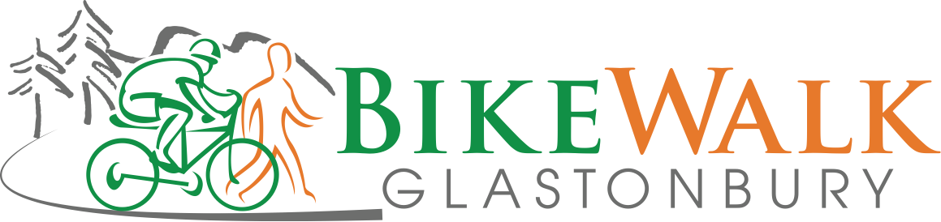

Minutes

June 12, 2017

- Plan of Conservation and Development
  - Reviewed last updates, all looked good
- Bike Friendly Facility—Deb, Dennis, Jeff
  - Agreed to $300 for window decals
  - Deb will be working with the Chamber of Commerce – support is there, just need to capitalize on the interest
- Bike to Work event report—Dennis, Deb
  - Small event, but enthusiastic attendees
- Goodwin College/Conservation Commission—Gerhard, Ron
  - Longer term vision is for a path that would connect Putnam to Bulkeley
  - Next immediate step is for natural surface trail to connect existing trail to Putnam before the winter (has been approved by the wetlands committee)
- Harvest Lane-Bell St. connection—Jeff
  - Options still being evaluated, Jeff to bring to the next BAG
- Bike Advisory Group update
  - School system looking to add cycling to physical education plan
  - Rumble strip discussion – nobody from BWG was aware of any discussions leading to plans for the strips on rt 17. Possible disconnect within BAG, but possibly only on the highway section so it would not be a concern. Deb to follow-up
- Tour of Glastonbury—Joe
  - Scheduled for September 10th
  - Joe will contact Jeff when his plans are further along. The Board will discuss possible sponsorship once that information is available
- Treasurer’s report—Ron
- September board and officer election
  - Per our bylaws elections for our board and officers will occur at our Sept. meeting. Jeff encouraged all who are interested in a board and/or officer position or are no longer interested in serving on the board to contact him between now and the Sept. meeting by either e-mail or phone.
- Miscellaneous
  - Ron mentioned that the public’s preferences for the route to close the Farmington Canal Trail through Plainville are being solicited on line.
  - Dan will check once again on the bike racks we donated for Riverfront Park, which have still not been installed. As the work on the river bank is being completed, we would expect the racks to be installed this season

