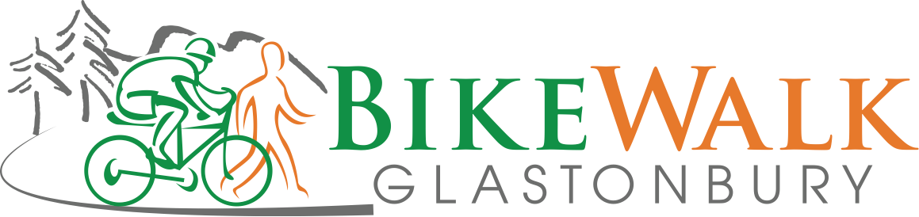

Minutes

Sept. 10, 2018

- Open discussion with Town Council Members
  - George Norman, Jill Barry, Larry Niland in attendance
  - Some discussion on desire to see Bell St to Harvest Lane segment;
    - concerns were raised that that segment currently presents a significant safety issue and past attempts to address that segment have been unsuccessful.
    - given that Western Blvd and House St is very far along we need to remain focus on finishing that project first
  - Possible ask – can we ask for an agenda item in the next two months for an update on town progress against bicycle master plan
  - Late January/Early February is when Capital Improvement Plan is opened to the public BWG can organize an influence campaign
  - Town Connectivity Report (Road Safety Audit) – doesn’t seem to have been presented to the Town Council
    - We can also request that the a presentation of the RSA be added to an upcoming Town Council report
    - It would make sense to also have BWG to take a few minutes to give an overview to the council on BWG priorities
  - In general, BWG needs to connect with the Town Council at least a couple of times throughout the year
    - BWG will need to make a formal request to get on an agenda for one of the upcoming Town Council Meetings for a 15 minute update
      - Jeff on point with help from Eileen, Dennis, and Deb
- Town projects update—Jeff
  - Cyclocross after school program update
    - Dr. Bookman clarified that the reason for rejecting the Cyclocross high-school program was not due to insurance but is instead due to the fact that there is an unsanctioned BMX course
    - BWG will need to appeal to the BoE
    - Allen Friedrich took responsibility for addressing the cyclocross club with the Board of Ed
- Bicycle scavenger hunt—Dennis, Deb
  - Motion Passed to fund up to $400 -- $300 for prizes and up to $100 for event supplies
- Bike rack for town center—Dan
  - BWG looking to see a bicycle rack installed near Daybreak
  - Next step would be for BWG to make a proposal by sharing design with town (Funding to be provided by BWG)
  - Jonathan, Allen Friedrich and Eileen volunteered
  - South Windsor is a good example
- BikeWalk roundabout review
  - The existing roundabout received a favorable reviews with a few minor suggestions.
  - Concerns raised about the slip lane design on the House Street round about
- Bike Friendly Facility update—Jeff Pipech
  - Jeff was not present, so Deb provided the town council a brief update
- Sustainable CT presentation—Dan
  - Dan recapped his presentation
- Cycling without Age presentation—Ron
  - Brief update from Jeff
- BWG brochure update
  - Jonathan and Dan to work on refreshing the Flyer
- Treasurer’s report
  - Update provided by Ron

Addendum:

BikeWalk Glastonbury History, Accomplishments and Goals

- 2005—Town Manager convened a meeting of those interested in advising the town on bicycling
- 2006—Group incorporated as Glastonbury Bikeways, Inc. Approved next year as 501(c)3 organization
- Bicycle Master Plan developed and approved by Town Council, including several updates
- Involved in planning multi-use trail from Smith Middle School to Bell St.
- 2012—Name changed to BikeWalk Glastonbury to encompass walking as well as bicycling, be consistent with state and national changes and recognize “complete streets” concept
- 2014—Worked with town staff to obtain Bicycle Friendly Community Bronze recognition from League of American Bicyclists (expires 2019)
- Participate in Bicycle Advisory Group (formed as part of Bike Friendly Community application), whose bimonthly meetings include representatives from Health, Engineering, Parks and Recreation, Police traffic division and School System as well as several BikeWalk members
- Gave input on update to Plan of Conservation and Development

- Successfully worked with the town to post Share the Road signs and install bike-friendly storm sewer grates
- Advocated for Putnam Bridge walkway and connecting trails and Western Blvd. to House St. multi-use trail, including feasibility study for Putnam Bridge connecting trails.
- Participated in Community Connectivity Audit—House St. to Riverfront Community Center
- Advocate for connections with East Hartford, Portland, Manchester

- Co-sponsor Bike Boulevard Scavenger Hunt with Parks & Recreation
- Cycling Without Age—planning bicycle rickshaw to allow seniors to have rides (partner with Housing Authority)
- Co-sponsored Tour of Glastonbury ride
- Bike Friendly Facility program—encourage and subsidize businesses to provide bike racks (partner with Parks & Red)
- Advocate for bike education/bike club in the school system (partner with Bike Advisory Group)
- Co-sponsored Bike to Work Day in May
- Donated helmets to needy youth (partner with Youth & Family Services)

GOALS
- Create multi-use, off-road trails for walkers, joggers, bikers, rollerbladers and the handicapped
- Enhance existing roads for a safe and more enjoyable walking and cycling experience
- Promote walking and biking as good options for both neighborhood and community transportation.

