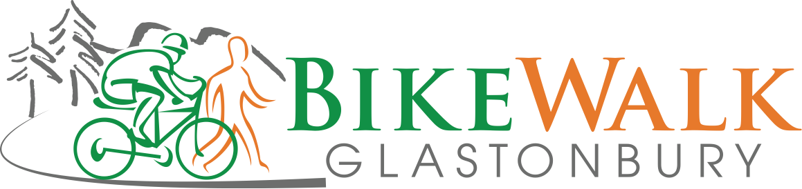

Minutes

June 10, 2019

- Town/State updates—Jeff
  - Glastonbury again recognized as bronze for Bicycle Friendly Community recognition
    - Town needs to engage school system to go further
    - Public recognition may occur at House St. trail opening
  - Next phase of bike path (to House Street) getting final approvals
    - Construction may start in July! Anticipated completion late this year
  - Putnam Bridge proposed connection paths were reviewed
    - 2021 is target to start construction, 2023 is target for opening
    - Goodwin College has extended its riverside trail and will pave part this year
  - School event being planned for fall kids bicycle education (Grades 4-5 for 1 afternoon)
  - Parks and Rec investigating cyclecross team for kids with CCAP
- Climate Ride 2019: having a really bad time while raising money for a really great cause—Dennis
  - See Dennis for presentation
- National Bike Summit Highlights—Sue Smith
  - See Sue for presentation
- Gift for Western Blvd./House St. trail
  - Some early discussion on planning of opening ceremonies for House St Trail
    - Recommendation to invite state commissioners Giulietti and Dice
  - Eileen to work on ideas for a Bike Walk gift
- Priorities
  - Should we do a survey? Let’s wait until league survey results come back
  - Discussion on priorities – final board approved list can be found here: http://www.bikewalkglastonbury.org/projects/bwg-current-priorities/
    - 3D was viewed as a long-shot – likely at best a crushed gravel path
    - 3C was viewed as a candidate to tie into the livable communities or further town’s Bicycle Friendly Community recognition (and longer-term tie into Putnam bridge)
      - Also it has opportunities to get short term wins
    - 3A has been high on several people’s list for a while
    - Decision – 3C should be our priority (and for now we can only take one priority to focus on)
      - Dennis to think about how to engage support
- Blessing of the bikes—Ron
  - Deferred to next meeting
- Treasurer’s report
  - Ron emailed copy to BWG Board
  - Vote passed to donate $75 to LAB to renew our membership
Note—Board election will occur at our September 9 meeting
- Ron and Jeff looking to step out of Treasurer and President role
- All interested in board positions are encouraged to contact Jeff prior to Sept. meeting.

