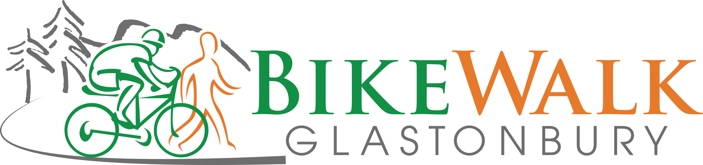

MINUTES

March 11, 2024

- Updates
  - The town Engineering Dept. has proposed a solution to the safety concern at the House St. trail driveway, which has limited sight lines. This would involve slightly narrowing vehicle travel lanes and widening shoulders between the driveway and House St.
  - A safety concern has been raised by this group and our Wethersfield counterparts regarding debris flying from the roadway to the path on the Putnam Bridge due to the low concrete barrier between them and the path being one foot lower than the main bridge deck. The CT DOT has decided not to address this issue as an addition to the current path completion. However, the state will hold a public meeting this April 4 about proposed rehabilitation of the bridge in 2026. Information about the proposal can be found at https://portal.ct.gov/DOTWethersfieldGlastonbury53-199 . Comments and questions can be submitted to the DOT until April 18. Members may wish to suggest adding fencing between the bridge roadway and trail. See the link for more information.
  - The Putnam Bridge trail with its connections is still tentatively scheduled to open April 15. Our board recently approved supplying a repair station and pump, which are currently being shipped and will be installed on the Glastonbury part of the trail.
  - Work on sidewalks and minor shoulder widening between Smith Middle School and the Western Blvd. trail, as well as National Drive, has been completed other than pavement markings.
  - The long-awaited section of sidewalk on Main St./Rt. 17 between the Cider Mill and Chestnut Hill Rd./Red Hill Dr. and signalized crosswalk at the southern end of that section are the subject of a public information meeting March 12. Members were encouraged to show their support.
  - Allen and Jeff recently met with Town Manager Jonathan Luiz to advocate for a trail to connect Bell St. and Harvest Lane.
  - The New England Mountain Bike Association has begun work on mountain bike trails connecting to the Smith School trail. The group may look to our group for financial support for the beginners’ area, but does not have a specific proposal at this time.
  - The Bicycle Advisory Group is compiling an end-of-trip facility survey.
  - The Glastonbury Physical Education staff is proposing an on-bike program. If the program is approved, our board recently agreed to fund a two-week rental of bikes for the first year of the program.
  - Rich and John are working on updating our brochure and will take some pictures to use in it this spring.
  - We will again have a table at the Earth Fair April 20.

II. The treasurer’s report was submitted to the board electronically.

